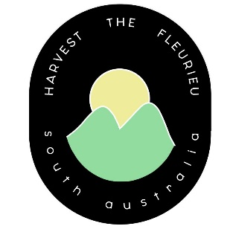
new stockist information pack

Business Name: ________________________________________________________
Contact Name: _________________________________________________________
Contact Email: _________________________________________________________
Product(s): ____________________________________________________________
Wholesale cost: ________________________________________________________
RRP: _________________________________________________________________

Please ensure you can complete our minimum requirements checklist:

Your product is made or grown in South Australia

Your label includes the correct country of origin food labelling
system commenced under the Australian Consumer Law (ACL).

If your product carries the ‘3 component’ logo it must be made with
a minimum of 50% Australian ingredients

Your label includes your business contact information

Your label includes a barcode

If you are unsure if your product requires ‘country of origin’ labelling please visit: ACCC Country of Origin Food Labelling.

